EXPERIMENT 9

Aim
Configure DHCP and SMTP in a small LAN

Prerequisite
Nil

Outcome
To impart knowledge of Computer Networking Technology

Theory
- Dynamic Host Configuration Protocol (DHCP)
DHCP is a network protocol used for the automatic configuration of IP addresses and other network parameters in a local network. In a Cisco Packet Tracer environment, DHCP plays a crucial role in simplifying IP address management. It allows a DHCP server to dynamically allocate IP addresses to client devices as they join the network. Key points to consider include:
  - IP Address Assignment: DHCP assigns IP addresses to devices within a defined range. This range is often referred to as a DHCP pool.
  - Lease Duration: Each IP address assignment comes with a lease duration, determining how long a device can use the assigned address. When the lease expires, the device may request a renewal.
  - Subnet Masks and Gateways: In addition to IP addresses, DHCP can provide subnet masks and default gateways, streamlining network configuration.
  - Conflict Resolution: DHCP servers detect and resolve IP address conflicts to prevent network disruptions.
- Simple Mail Transfer Protocol (SMTP): SMTP is a protocol used for sending and receiving email messages. In the context of Cisco Packet Tracer, SMTP is employed to simulate email communication. Key aspects to consider include:
  - SMTP Server Configuration: To enable SMTP communication, an SMTP server is configured on a specific PC. This server handles the sending and receiving of email messages.
  - Email Clients: Other PCs in the network are configured as email clients, and they use the SMTP server for sending outgoing emails. The server routes these messages to their destinations.
  - Email Accounts: Proper configuration of email accounts on the email clients is essential for sending and receiving messages. This typically includes settings for incoming and outgoing email servers, usernames, and passwords.
  - Email Routing: SMTP is responsible for routing email messages from the sender to the recipient's mailbox. It communicates with other SMTP servers on the internet to relay messages.
Understanding DHCP and SMTP is fundamental in network management and communication within Cisco Packet Tracer simulations, as these protocols automate IP address assignments and email transmission, ensuring efficient and reliable networking and messaging services.

Procedure
  - Setting Up DHCP in Cisco Packet Tracer:
  - Launch Cisco Packet Tracer and create a new project.
  - Add a router, a switch, and multiple PCs to the workspace.
  - Configure the router and switch as needed to create a LAN.
  - Set up a DHCP server on one of the PCs within the LAN.
  - Configure the DHCP server to define the IP address range and lease duration.
  - Connect client PCs to the switch and set them to obtain IP addresses automatically.
  - Observe the IP address assignment process and network connectivity within the simulation.
  - Configuring SMTP in Cisco Packet Tracer:
  - Add a server (another PC) to the workspace for hosting the SMTP server.
  - Configure the server as an SMTP server and set up email accounts.
  - Configure email clients on other PCs to use this SMTP server for sending emails.
  - Send test emails between clients to observe the SMTP communication within the Cisco Packet Tracer simulation.
Output
- DHCP
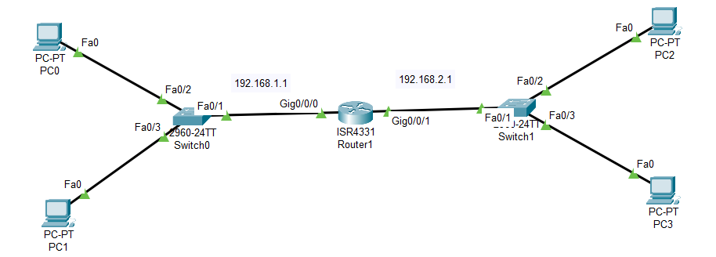

Router Configuration
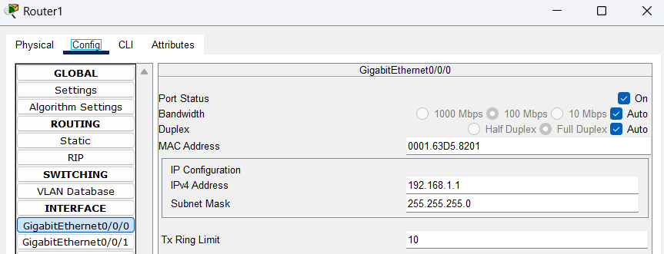
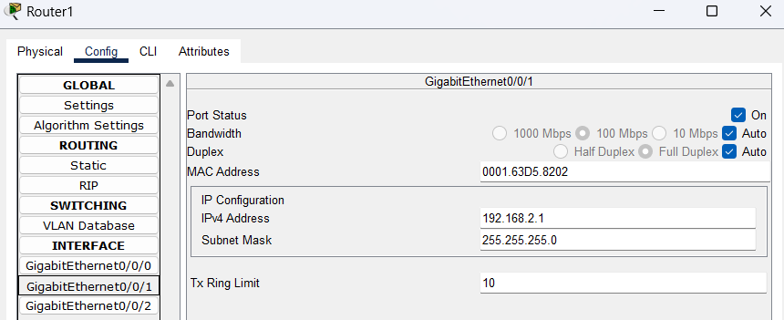

DHCP Configuration
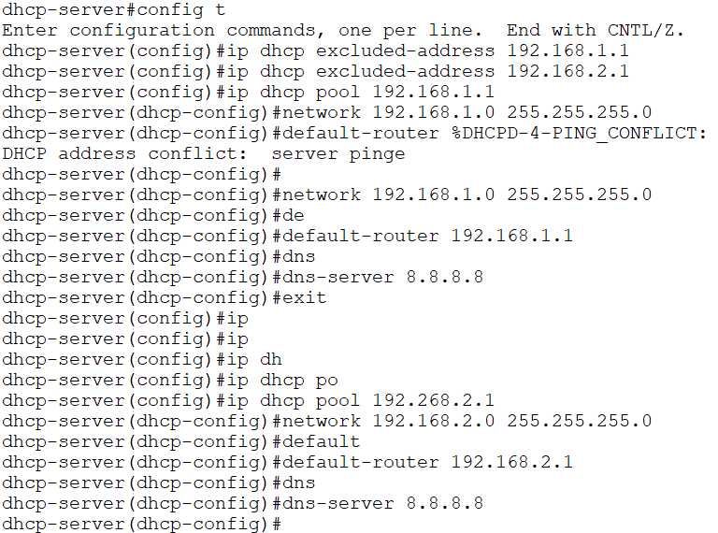

IP Address assigned to PCs
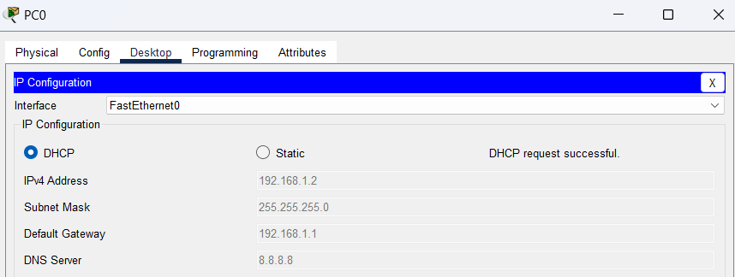
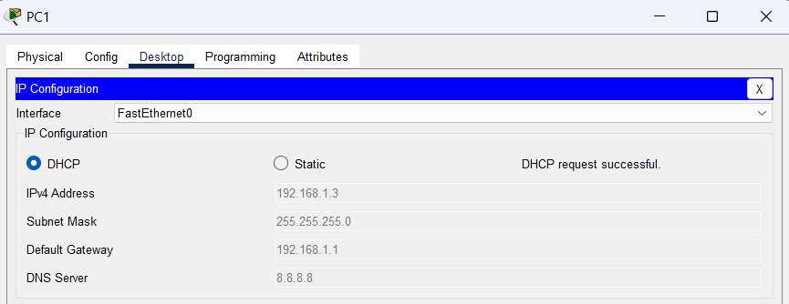
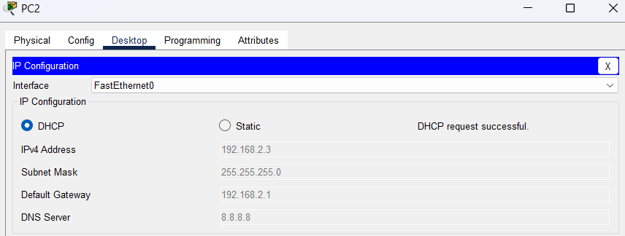
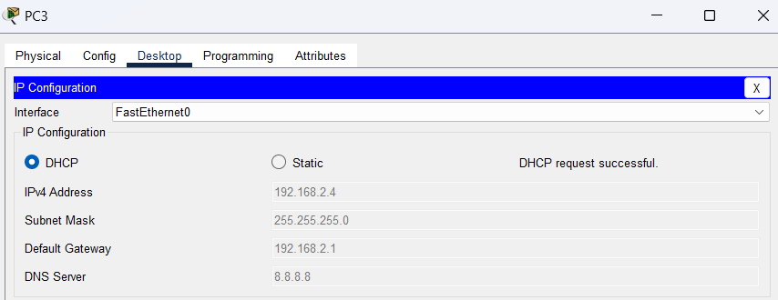
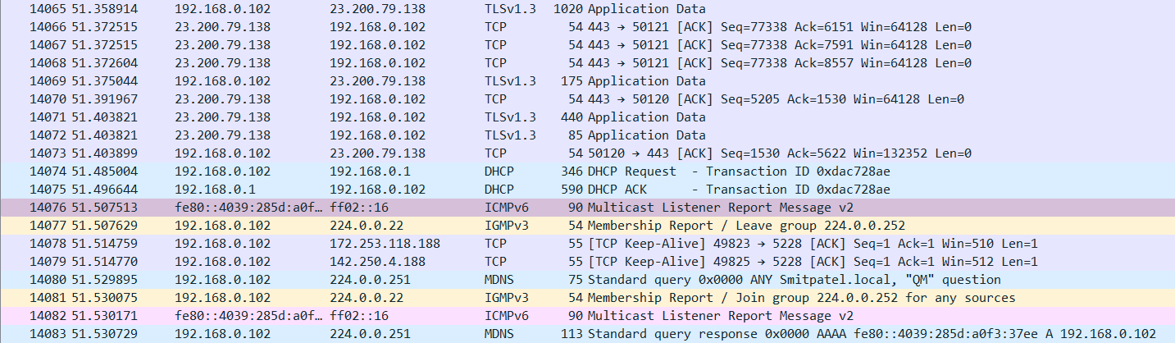

- SMTP
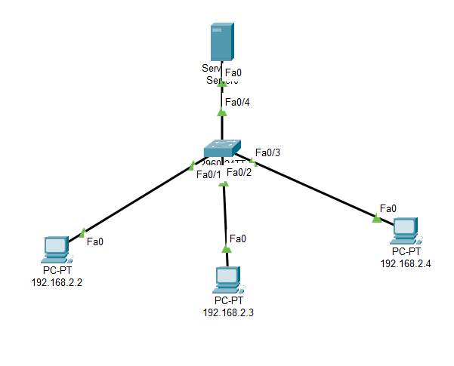
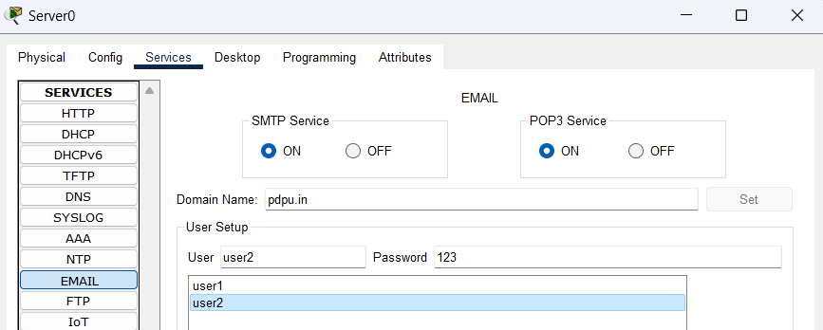
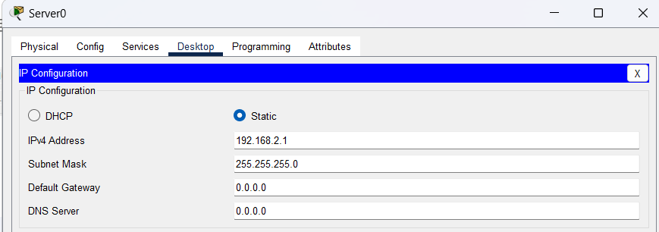
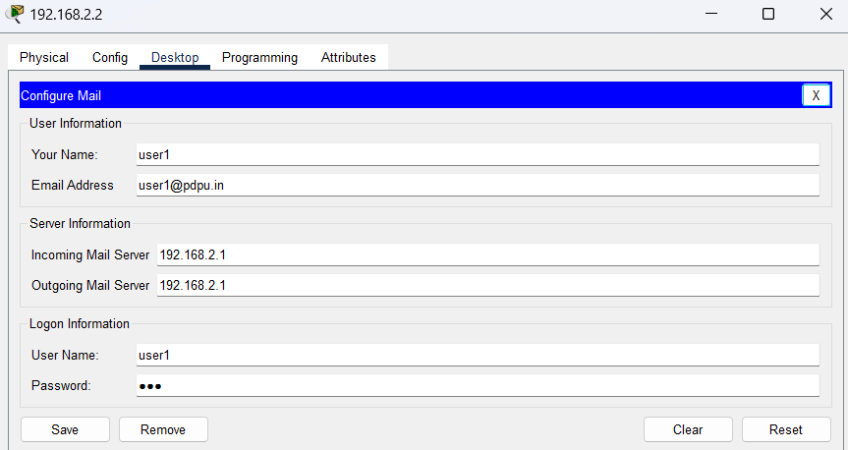
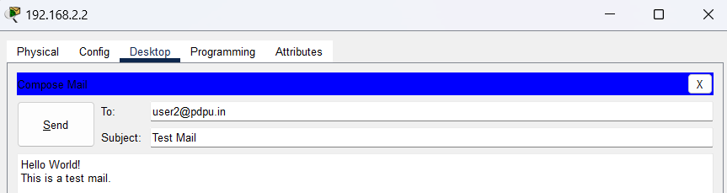
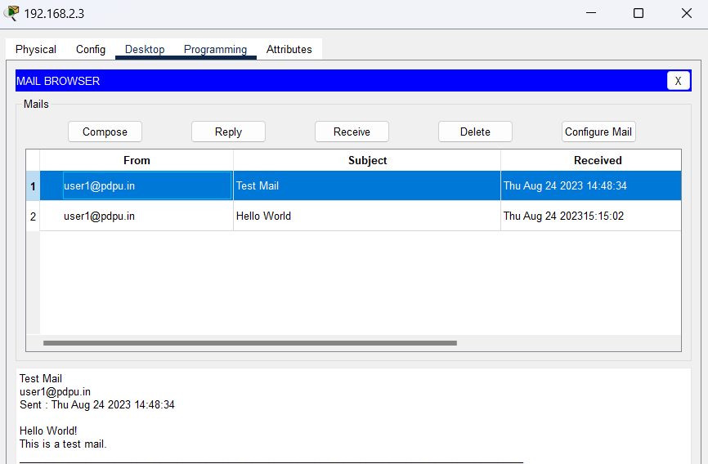
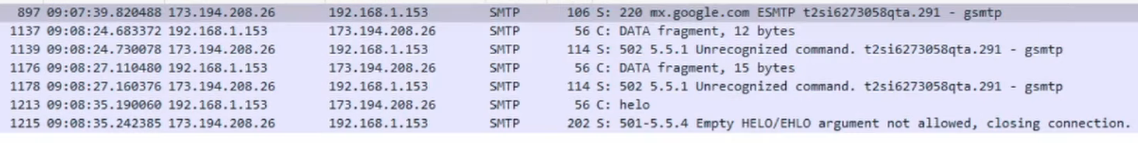2
Observation & Learning
- DHCP successfully assigned IP addresses, subnet masks, and gateways to client PCs, demonstrating efficient network parameter management within Cisco Packet Tracer.
- SMTP facilitated seamless email communication as messages were routed through the SMTP server, emphasizing its role in relaying emails.
- Network connectivity was established swiftly, allowing clients with dynamically assigned IP addresses to access the internet and interact within the LAN.
- The experiment exhibited rapid response times for DHCP lease assignments and email message delivery, ensuring prompt network and communication services.
- Error handling mechanisms for DHCP and SMTP were observed, showcasing automatic resolution of issues like IP conflicts and email address validation, enhancing network reliability.
Conclusion
In this experiment, we successfully configured DHCP and SMTP services within a small LAN simulation. DHCP simplified IP address management, and SMTP facilitated the transmission of email messages. These services are essential for efficient network management and communication in real-world networks as well as simulations.
Questions
- What are the different ports used by the DHCP and SMTP within the Cisco Packet Tracer environment?2
In Cisco Packet Tracer, the port numbers used by DHCP and SMTP are the same as in real-world scenarios. DHCP uses UDP port 67 for the server and UDP port 68 for the client. SMTP uses TCP port 25.
- What are the benefits of using DHCP services in Cisco Packet Tracer simulations and real networks?
- DHCP simplifies IP address management, reducing the risk of IP address conflicts in Cisco Packet Tracer simulations and real networks.
- It automates the configuration of network parameters, such as subnet masks and gateways.
- It makes it easier to add and remove devices from the network without manual IP configuration.
- What is the role of Active Directory in the DHCP context within Cisco Packet Tracer?
In Cisco Packet Tracer simulations, Active Directory may not be available. However, in real-world networks, Active Directory can be used to store and manage DHCP server configuration information, providing centralized DHCP management, security, and access control features.

